|  |  |  |
| --- | --- | --- |
| WNP | wnpmastercon@GWNPX1 | (description=(address=(protocol=tcp)(host=t1tlg1c49.dadc.sbc.com)(port=1521))(connect_data=(server=dedicated)(service_name=gwnpx1.db.att.com))) |

TOTAL COUNT-

SELECT COUNT(*) FROM WNP_REPLAY_TRX@WNP_DB ;

350024

SELECT COUNT(*) FROM WNP_REPLAY_TRX_HIST@WNP_DB;

860461

Elogible count to delete 12 months TLG-112

SELECT COUNT(*) FROM WNP_REPLAY_TRX@WNP_DB ;WHERE SYS_CREATION_DATE<TO_DATE('27-09-2023','DD-MM-YYYY');--349748 WNP_REPLAY_TRX_HIST

SELECT COUNT(*) FROM WNP_REPLAY_TRX_HIST@WNP_DB; WHERE SYS_CREATION_DATE<TO_DATE('27-09-2023','DD-MM-YYYY');--860461 WNP_REPLAY_TRX_HIST

Op_app_data

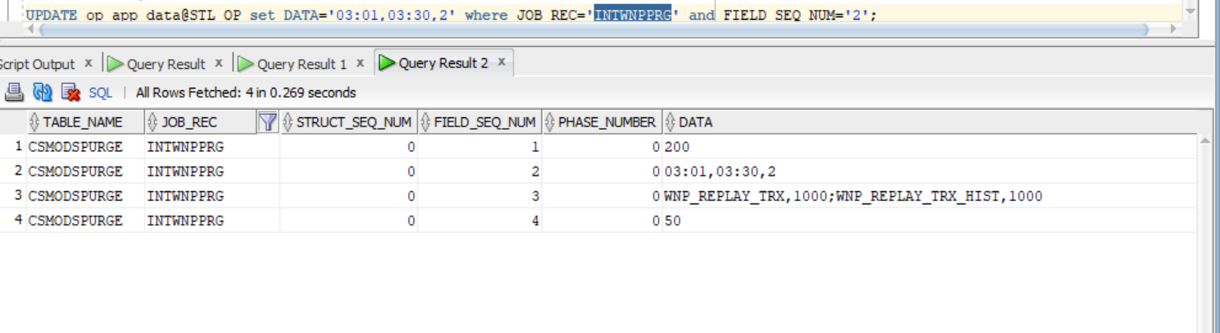

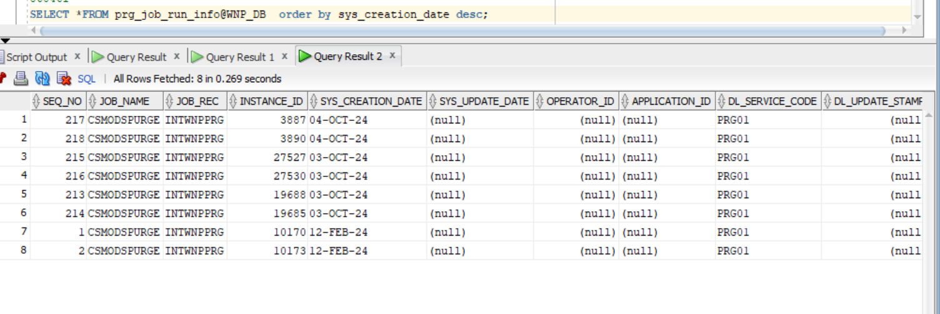

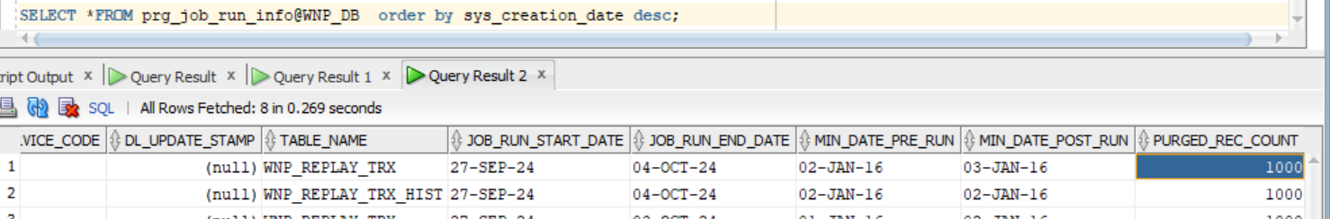

AFTER RUNNING PURGE JOB

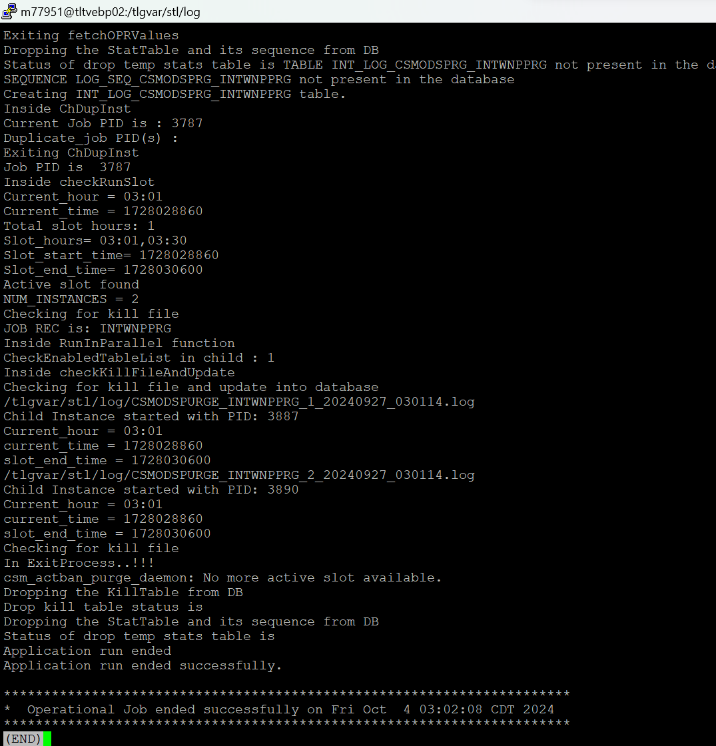

CSMODSPURGE_INTWNPPRG_2_20240927_030114.log

CSMODSPURGE_INTWNPPRG_1_20240927_030114.log

CSMODSPURGE_INTWNPPRG_STL_20241004_030106.log

Count reduced by 1000

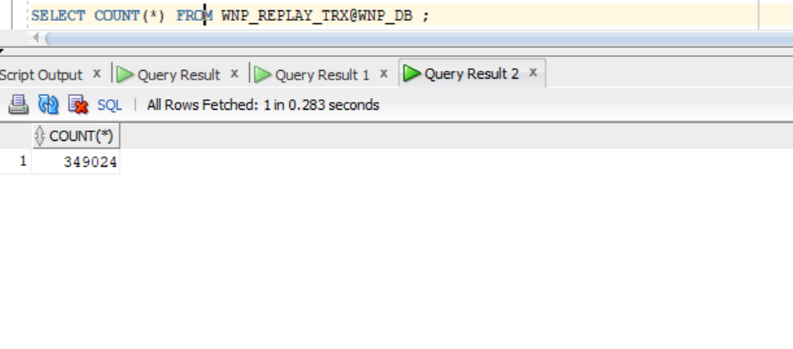

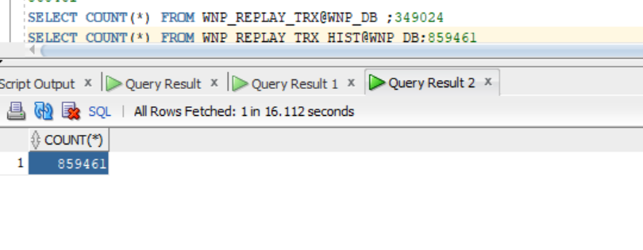

SELECT COUNT(*) FROM WNP_REPLAY_TRX@WNP_DB ;349024

SELECT COUNT(*) FROM WNP_REPLAY_TRX_HIST@WNP_DB;859461

